**Screenshots Ken Ho**

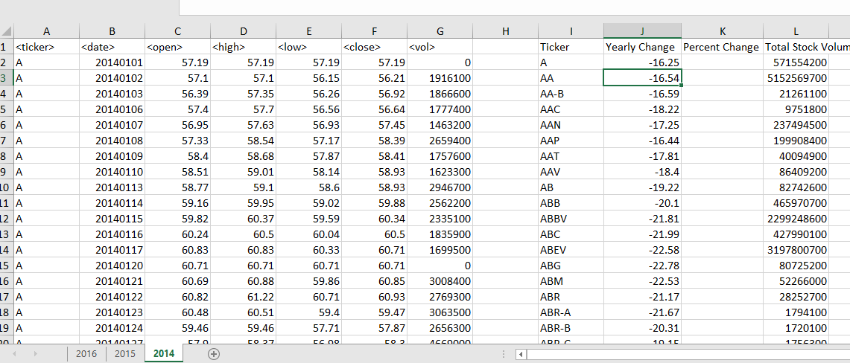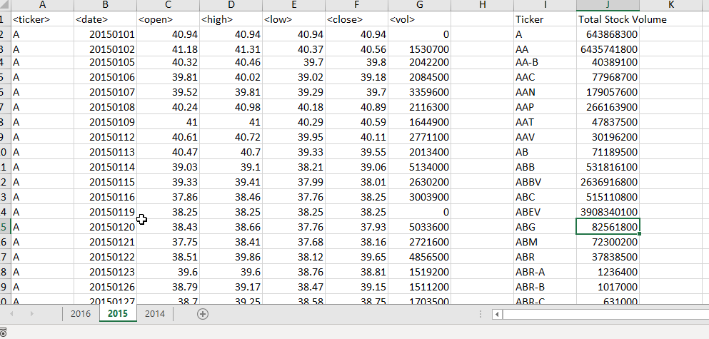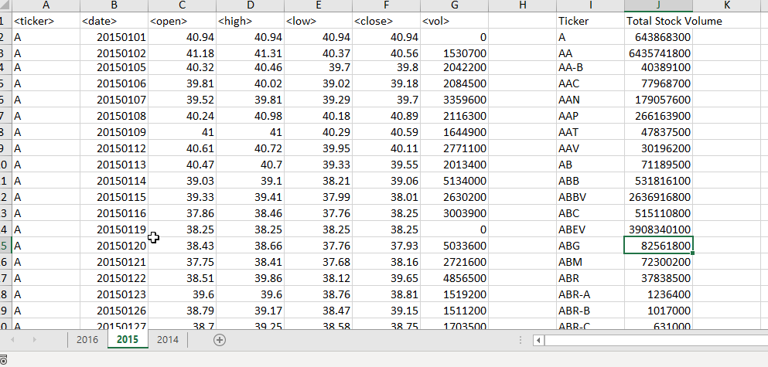

**VBA Script Ken Ho**

Sub stock()

'do dimensions

Dim ws As Worksheet

Dim Total As Double

Dim J As Integer

Dim i As Long

For Each ws In Worksheets

'set variables for each sheet

Total = 0

J = 0

'obtain row number of the last row of data

RowCount = Cells(Rows.Count, "A").End(xlUp).Row

'do title for the rows

ws.Range("I1").Value = "Ticker"

ws.Range("J1").Value = "Total Stock Volume"

For i = 2 To RowCount

'if ticker change, print data

If ws.Cells(i + 1, 1).Value <> ws.Cells(i, 1).Value Then

'print ticker

ws.Range("I" & 2 + J).Value = ws.Cells(i, 1).Value

'print total

ws.Range("J" & 2 + J).Value = Total

'reset total

Total = 0

'move to next row

J = J + 1

'or else keep adding to the total volume

Else

Total = Total + ws.Cells(i, 7).Value

End If

Next i

Next ws

End Sub